**Problems:**

Citibank has a requirement for an application that will allow fund managers to manage customer’s portfolios. Fund Managers need to be able to add or remove assets from their portfolios as well as modify the positions of each portfolio as required. Additionally Citibank needs to be able to allow designated administrators the ability to manage the application, to add and remove fund managers from funds and portfolios as required. What’s more, Citibank should visualize the data for fund managers and administrator.

**Solutions:**

We will create an application using vue & spring boot technologies that will create a robust and scalable environment to allow Citibank to automatically manage portfolios and funds for its fund management. Besides, the application can allow administrator to manage the fund managers. In addition, we will use Element UI and Echarts to implement the visualization module.

**Architecture diagram:**

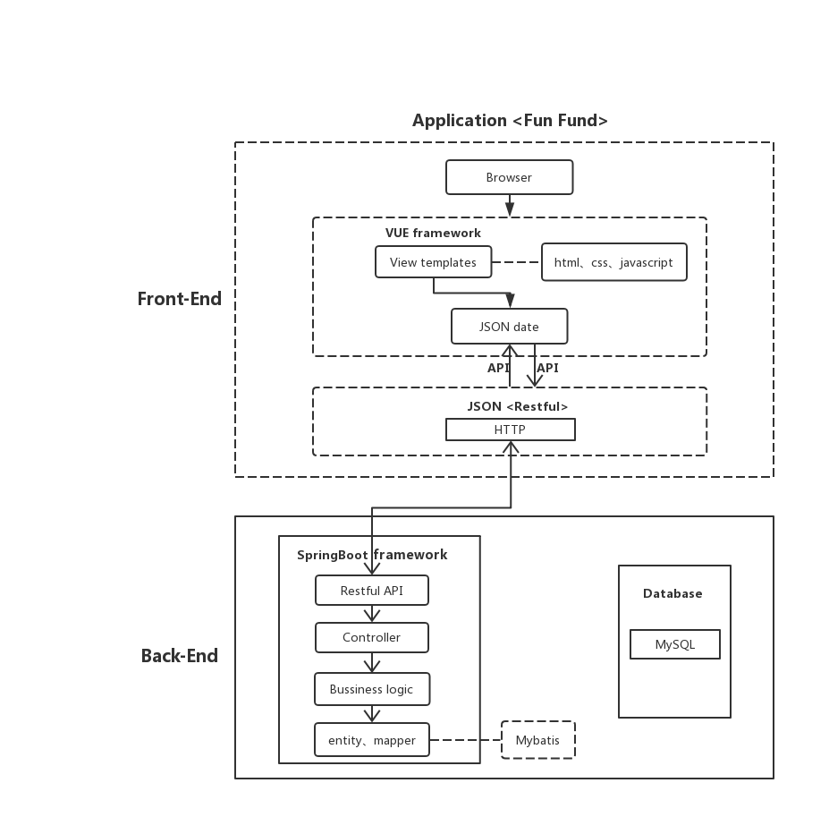

**Function Module Diagram:**

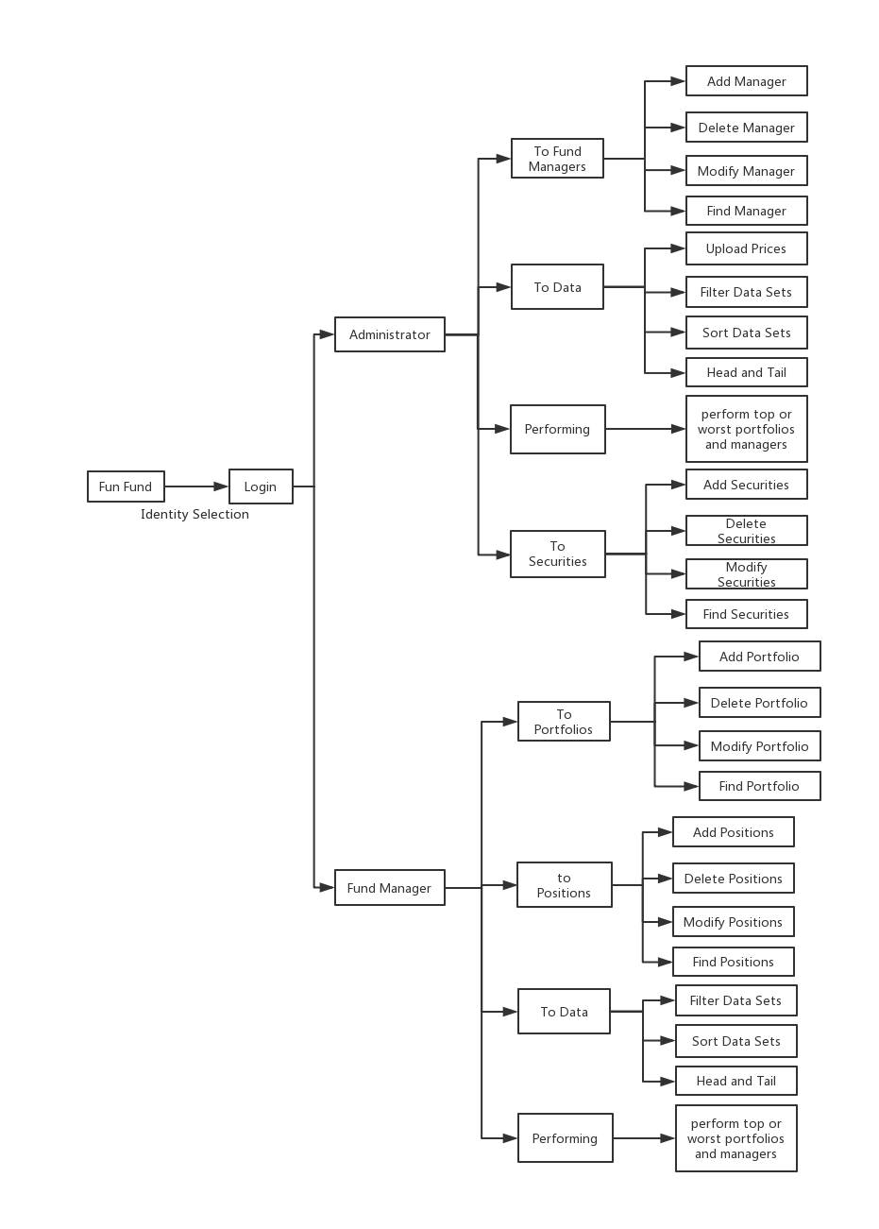

**Core Features:**

**For administrator:**

1. Fund Manager Maintenance:

* Add fund manager.
* Delete fund manager
* Modify fund manager
* Find fund manager

1. Securities Maintenance:

* Add securities .
* Delete securities
* Modify securities
* find securities

1. Data Maintenance:

* Upload Prices.
* Filter data sets
* Sort data sets
* Head and tail

1. Performing

* Perform top or worst portfolios and managers

**For fund manager:**

1. Portfolios Maintenance:

* Add portfolio
* Delete portfolio
* Modify portfolio
* Find portfolio

1. Positions Maintenance:

* Add position.
* Delete position
* Modify position
* find position

1. Data Maintenance:

* Filter data sets
* Sort data sets
* Head and tail

1. Performing

* Perform top or worst portfolios of this manager

**Optional Features:**

* Transfer the portfolios between fund managers
* Price Maintenance
* URL’s encryption